Export dynamic data

Data from a Survey must be downloadable by click a button ‘Download observations’ at Survey level:

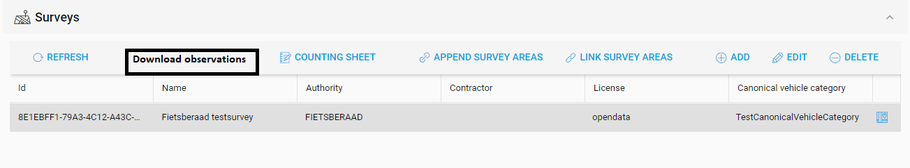

Get the data by endpoint:

GET http://remote.veiligstallenontwikkel.nl/rest/api/v2/surveys/<survey.id>/combinedobservations



You’ll receive an array of so called Combined Observations. A Combined Observation is an occupation observation combined with a capacity observation:

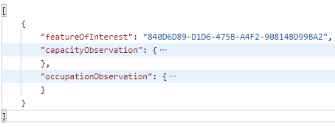

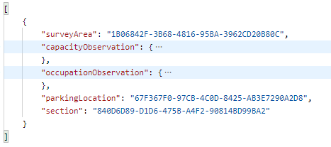

This response must be converted into a **Excel sheet** (no CSV!) with columns like in:

<https://docs.google.com/spreadsheets/d/1z3ECyDDUbYOoj8uu6Y-oyZTM6v1fIyJ_jDd_qXGfhr0/edit#gid=0>

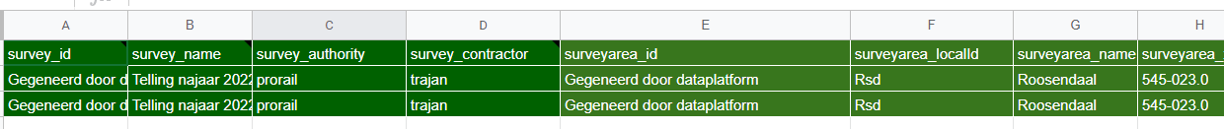

Properties for Section, Parking-Location and Survey-Area, such as names and local IDs can be retrieved by these endpoints.

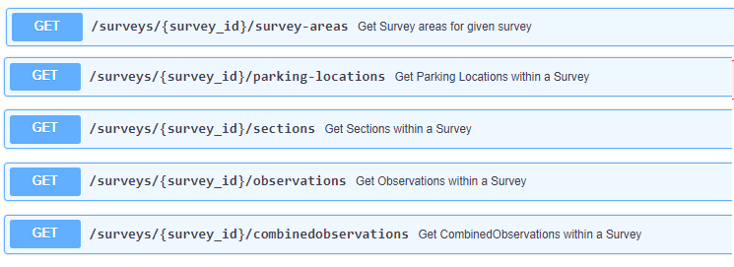

# Mapping:

survey_id: Survey.id

survey_name: Survey.name

survey_authority: Survey.authority

survey_contractor: Survey.contractor

surveyarea_id: SurveyArea.id (SurveyArea with empty or no property ‘parent’)

surveyarea_localId: SurveyArea.localId

surveyarea_name: SurveyArea.name

surveyarea_xtrainfo: SurveyArea.xtrainfo

surveyarea_localId_child: child SurveyArea.id (optional, child is surveyArea with prop parent filled)

surveyarea_name_child: child SurveyArea.name (optional, child is surveyArea with prop parent filled)

geolocation: https://remote.veiligstallenontwikkel.nl/rest/api/v2/parking-locations/<parking-location.id>, https://remote.veiligstallenontwikkel.nl/rest/api/v2/sections/<section.id>

parkinglocation_id: parkinglocation.id

parkinglocation_localId: parkinglocation.localId

parkinglocation_name : parkinglocation.name

parkinglocation_locationFeatureType : comma separated list of parkinglocation.features

parkinglocation_xtrainfo: parkinglocation.xtrainfo

section_id: section.id

section_localId: section.localId

section_name: section.name

section_layout: section.layout

section_parkingSystemType: section.

section_vehicleOwnerType: section.

section_level: section.level

observation_capacity_id: capacityObservation.id

observation_capacity_timestamp_start: capacityObservation.timestampStart

observation_capacity_timestamp_end: capacityObservation.timestampEnd

observation_capacity_parkingCapacity: capacityObservation.parkingCapacity

observation_capacity_note: capacityObservation.note

observation_occupation_id: occupationObservation.id

observation_occupation_timestamp_start: occupationObservation.timestampStart

observation_occupation_timestamp_end: occupationObservation.timestampEnd

occupation_totalParked: occupationObservation.measurement.totalParked

observation_occupation_note: occupationObservation.note

Get Canonical Vehicles for survey:

[https://remote.veiligstallenontwikkel.nl//rest/api/v2/canonical-vehicle-categories/<survey.canonicalVehicleCategory>/canonical-vehicles](https://remote.veiligstallenontwikkel.nl//rest/api/v2/canonical-vehicle-categories/%7Bsurvey.canonicalVehicleCategory%7D/canonical-vehicles)

Create a column for each Canonical Vehicle and get its data from the occupationObservation.measurement.vehicleTypeCount with prop canonicalVehicleCode = canonicalVehicle.code

<canonicalVehicle.code> <canonicalVehicle.description>: occupationObservation.measurement.vehicleTypeCount.numberOfVehicles

All timestamps in **local time** format:

**d-m-yyyy H:mm:ss**

So no leading zeros:

Example:

6-7-2023 9:03:02 = 6 July 2023 09:03:02

23-12-2023 19:03:02 = 23 December 2023 19:03:02

(If converting UTC timestamps to local time is too complicated, keep UTC timestamp (like 2023-01-01T02:00:00+0100).